RECIPE  
New England Clam Chowder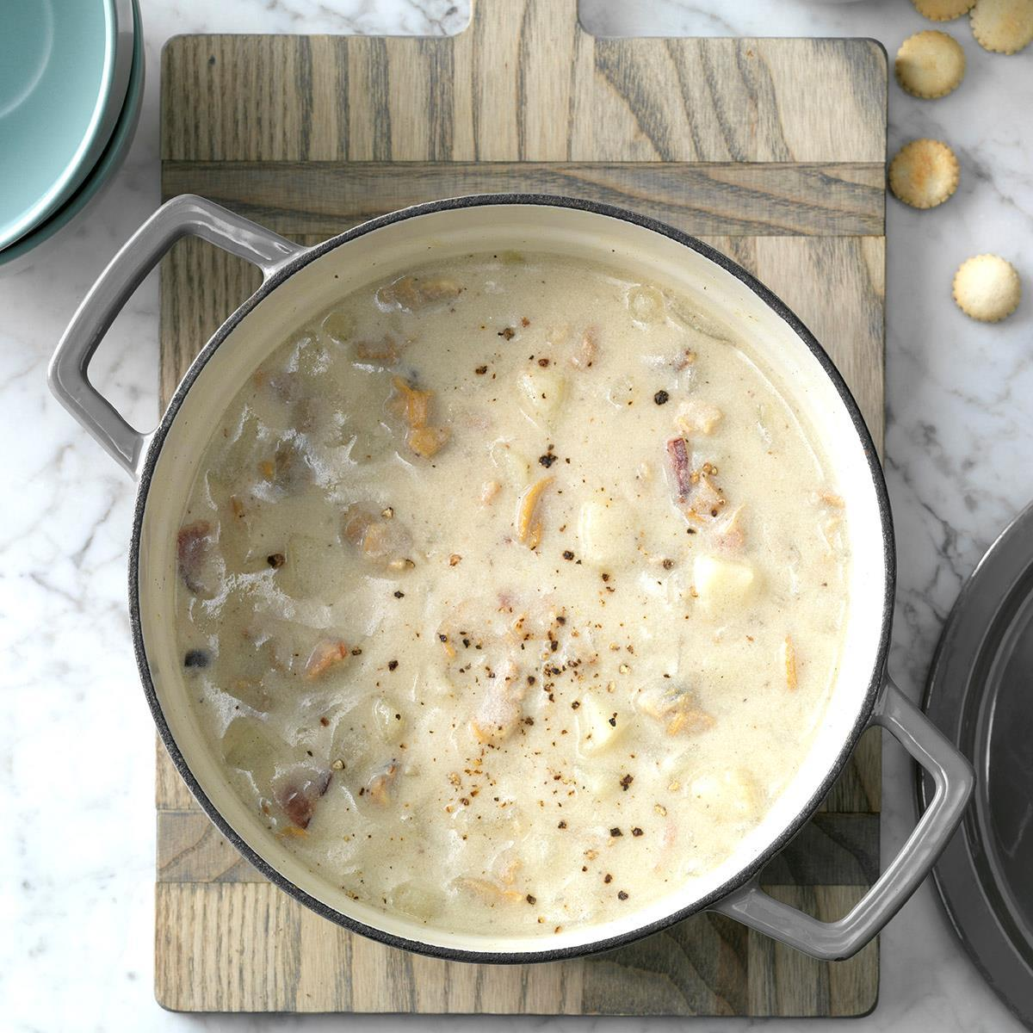

Serves 4

# Ingredients

* 2 tbsp unsalted butter
* 1 onions
* 2 celery stalks, sliced
* ¼ cup all purpose flour
* 2 cups vegetable stock
* 2 (10 oz) cans chopped clams in juice
* 1 cups heavy cream
* 2 large bay leaves
* 1 pounds potatoes, cut into ½ inch cubes
* Salt and pepper to taste

# Preparation

1. Heat butter in large pot over medium-high heat
2. Add the onion and the celery and saute until softened, mixing often
3. Stir in flour and distribute evenly
4. Add the stock, juice from the clams, cream, bay leaves, and potatoes and stir to combine
5. Bring to a simmer, stirring constantly until the mixture thickens
6. Reduce the heat to medium-low and cook for 20 mins, stirring often, until the potatoes are tender
7. Add the clams and season to taste with salt and pepper and cook until the clams are heated through